E-Connect Installation and Configuration Steps

- Install IIS on client system.
- Copy E-Connect folder in Candela RMS folder.
- Change connection string web.config in E-Connect folder.
- Create website in IIS.
- Link website with E-Connect folder.
- Run newly create website. Following page will return.

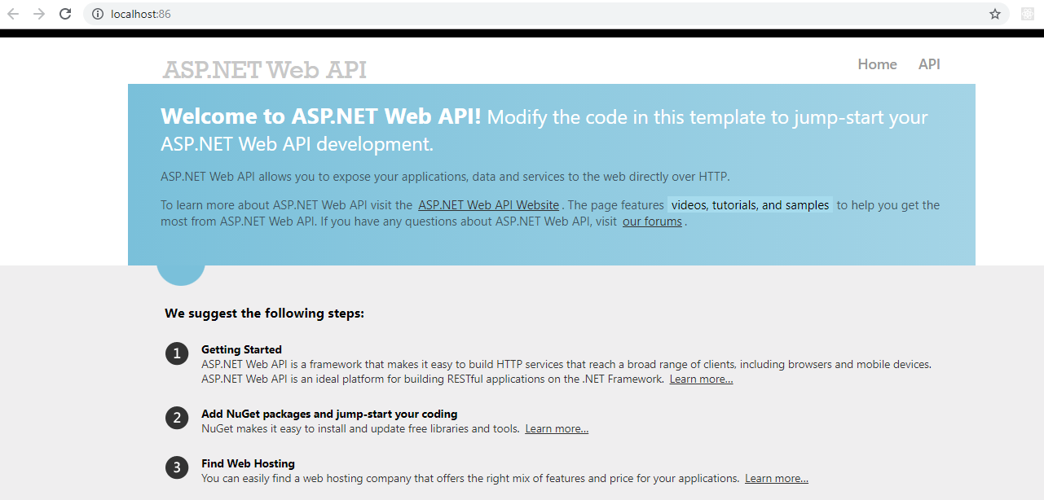

- Sync E-Connect Credentials from Configuration > Register Candela Online
- Check E-Connect credentials in Candela about box.
- Run any API like inventory etc on local host.
- Run same API on static IP.
- Both APIs should return data in browser, if there is any exception then diagnose
- After successfully run, share credentials and API document with customer.

